Media Release

Schaffhausen (Switzerland), 20. January 2026
Avoid stagnation, ensure drinking water hygiene: the new Hycleen Flush digital flush valve from GF
Reliable flushing and documented water replacement: GF's new Hycleen Flush digital valve is a system for automated stagnation flushing, ensuring safe drinking water hygiene in cold and hot water pipes. Designed for easy installation, Hycleen Flush with automated and documented water change is the flexible solution for both new buildings and renovation projects, reducing the risk of stagnation and Legionella growth in drinking water, especially in properties with different phases of use. The valve, which can alternatively be operated with a flow sensor, supplemented with drain monitoring, or used as a shut-off solution, meets all the documentation requirements of modern hygiene standards thanks to its integrated documentation.

With Hycleen Flush from GF, the market leader in flow solutions for buildings, industry, and infrastructure offers a new digital valve for reliable and high drinking water hygiene. The system automates the flushing of cold and hot water pipes based on defined, digitally controllable parameters (temperature, time, consumption) and also documents this in a process-controlled manner. Since the valve only performs flushing when necessary, it reduces water consumption.

Hygiene risk due to irregular flushing
The risk of stagnation and Legionella growth increases particularly in buildings that are not used continuously or are used with varying intensity, such as hotels, schools, daycare centers, hospitals, retirement and nursing homes, office buildings, and vacation apartments. Regular flushing of cold and hot water pipes counteracts this, but in buildings that are temporarily vacant, this involves additional work for operators or building managers. Hycleen Flush is an automated flushing system that addresses this challenge: flushing intervals are set via an app or the building management system and then carried out automatically. At critical temperatures (>20°C), the valve flushes automatically. If the system is equipped with a flow sensor (optional), Hycleen Flush also starts flushing automatically when water consumption falls below a defined level. External sensor signals control flushing flexibly as required, for example depending on chlorine value, pressure, or flow.

Flexible use, quick commissioning, documented processes
The digital valve is suitable for new buildings and renovations and, thanks to its compact size and uncomplicated installation, is ideal for retrofitting. In addition to mobile phones or tablets, Hycleen Flush can be connected, parameterized, monitored, and controlled via the Modbus interface with any building technology. Thanks to the open communication interface (Modbus-RTU), the system can be integrated easily and flexibly. Automatic data logging reliably documents flushes and temperatures, helping to ensure compliance with all operator obligations. The data is available at any time, both via the mobile app and centrally via the Modbus connection to the building management system. Quick start: The commissioning wizard allows setup in less than five minutes per valve. Flexible cabling with pre-assembled cables simplifies installation and saves valuable time. This makes it a reliable solution for installers, planners, architects, engineers, and operators alike.

Hycleen Flush as a shut-off solution that thinks for itself
In its function as a shut-off valve, Hycleen Flush offers an intelligent solution for protecting water-carrying systems. The pipes can be shut off according to defined parameters such as time control, based on temperature or humidity sensors, or closed, monitored, and documented manually via the app or the building management system. This ensures clear control and high operational reliability. The function is selected during planning, as the installation locations in the building vary depending on the application. This allows water flow to be intelligently controlled, reacting to environmental conditions such as frost or leaks and increasing operational safety. The application is available in DN 15 and DN 20 and is ideal for compact installation situations.

Hycleen Flush as an automated flushing solution:
- Performs automatic flushes based on time, temperature, or consumption
- Setup and control of flush speed/opening degree via Bluetooth app and Modbus
- Up to two external sensors can be integrated
- Ideal for non-circulating pipes in hotels, hospitals, and sports facilities
- Easy to retrofit
- Saves water and project costs, reduces manual intervention, and lowers liability risks

Hycleen Flush as an automatic shut-off solution:
- Automatic shut-off when needed or in an emergency; triggered by time, sensor, switch, or BMS
- Control via Bluetooth app or Modbus
- Up to two external sensors can be integrated
- For frost protection, leak prevention, or controlled water supply (DN 15/20)
- Protects against damage and offers remote access with user management

For further information please contact
Beatrix Pfundstein
Senior Communications Manager
Building Flow Solutions
Global Communications
beatrix.pfundstein@georgfischer.com
Mobile +49 172 8599240

Corporate Profile
With a rich history in industrial innovation since 1802, GF is actively reshaping itself to become the global leader in Flow Solutions for Buildings, Industry and Infrastructure. GF delivers Excellence in Flow through essential products and solutions that enable the safe and sustainable transport of fluids worldwide. As part of its strategic transformation, GF divested GF Machining Solutions on 30 June 2025 and has signed an agreement to divest its GF Casting Solutions division. Headquartered in Switzerland, GF employs about 15’700 professionals and is present in 46 countries. GF generated sales of CHF 4’776 million in 2024. GF is listed on the SIX Swiss Exchange.
#ExcellenceInFlow
www.georgfischer.com
www.uponor.com
You can register for our subscription service for journalists at www.georgfischer.com/aboservice. You will automatically receive our current media releases.

Pictures
Reprint free of charge // please note the copyright information //
please provide copy of magazine or a link to the online publication

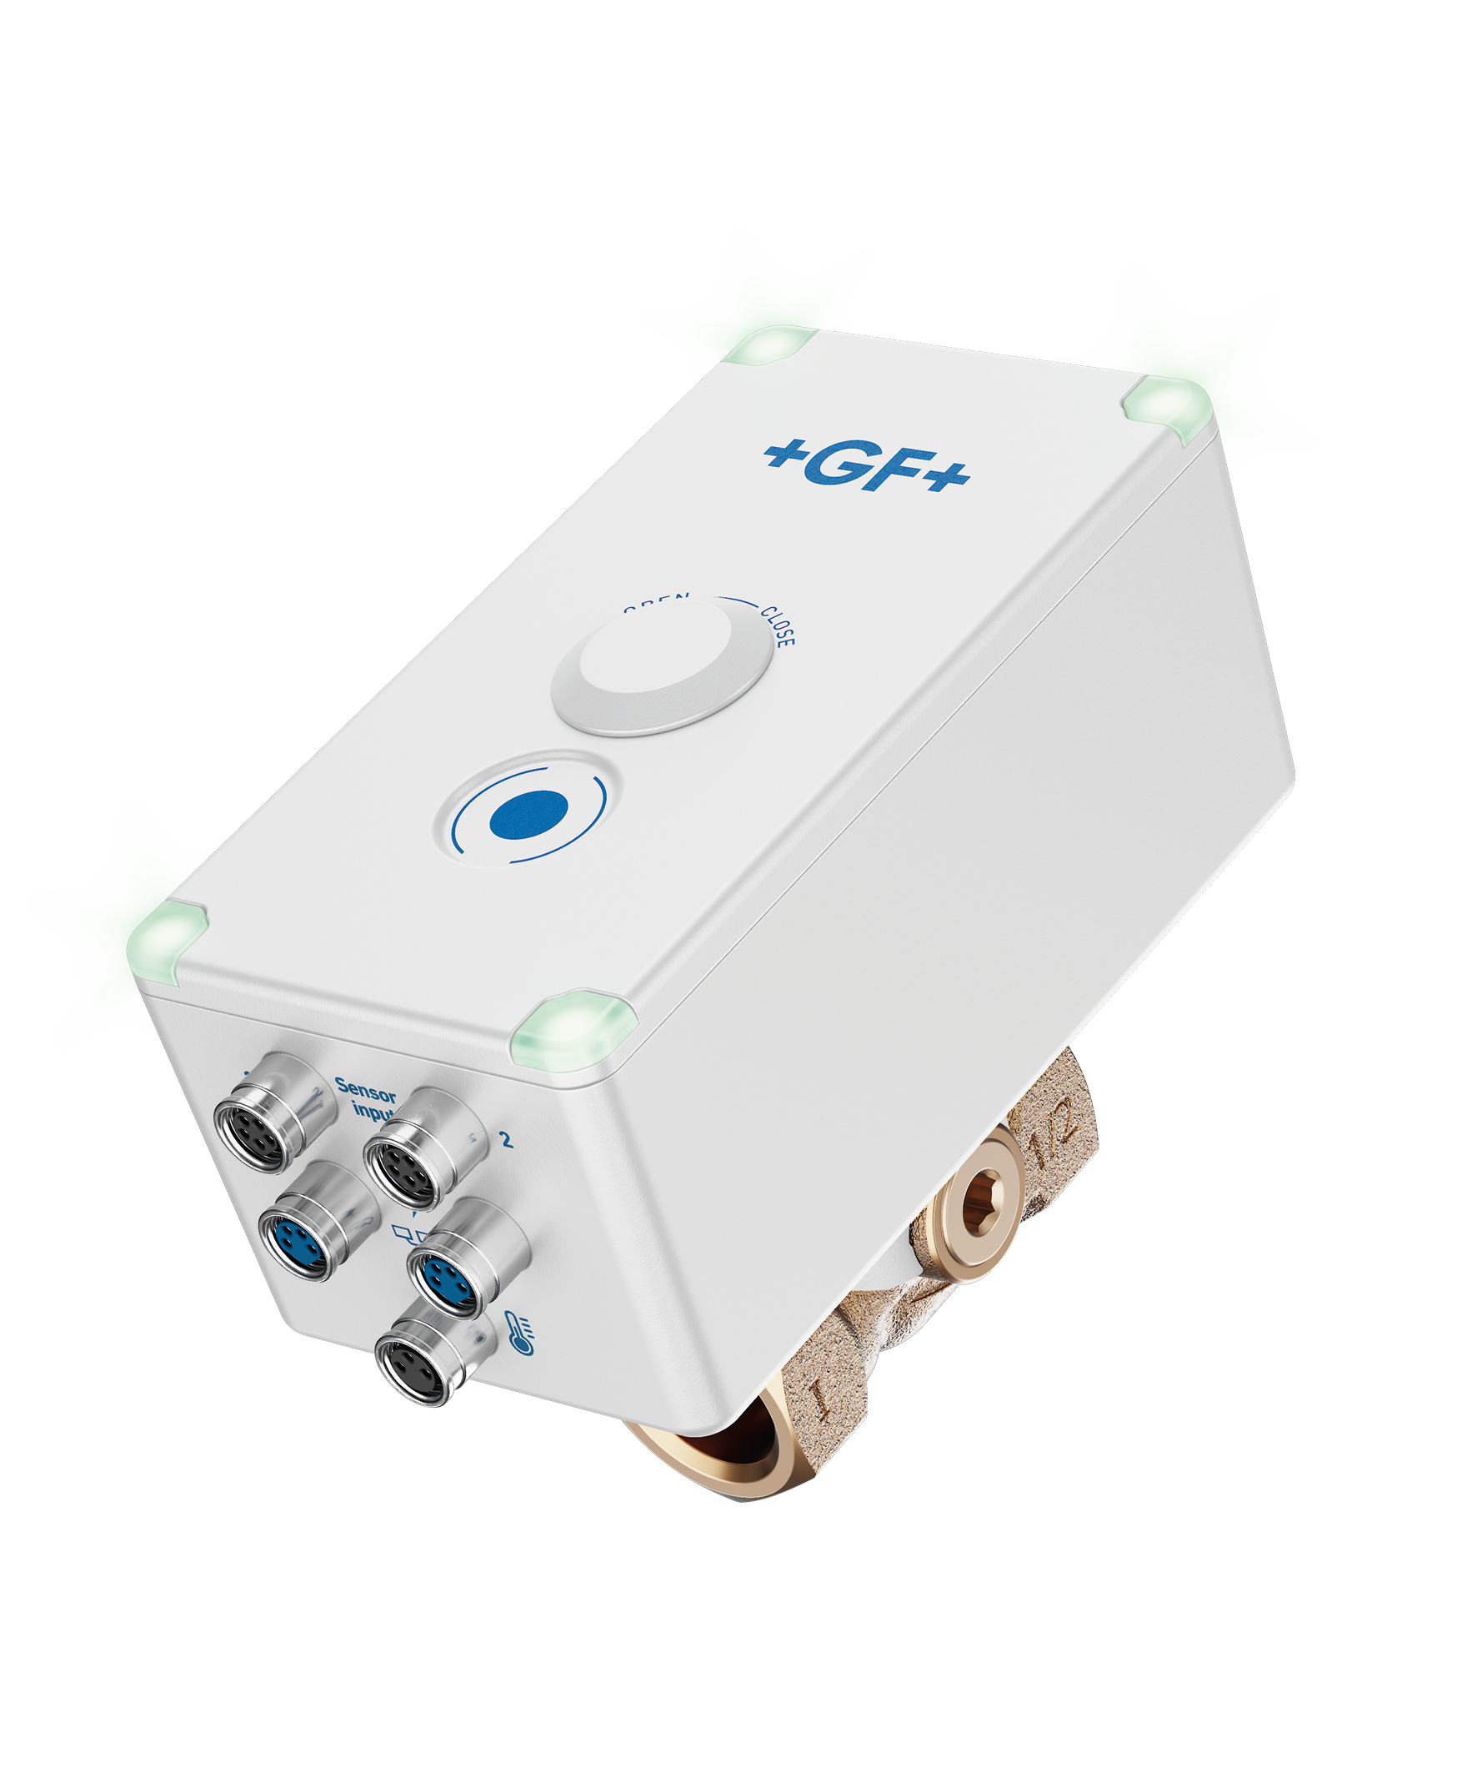 | GF_Hycleen_Flush_1.jpg  Avoid stagnation, ensure drinking water hygiene: the new Hycleen Flush digital flush valve from GF  Source: GF
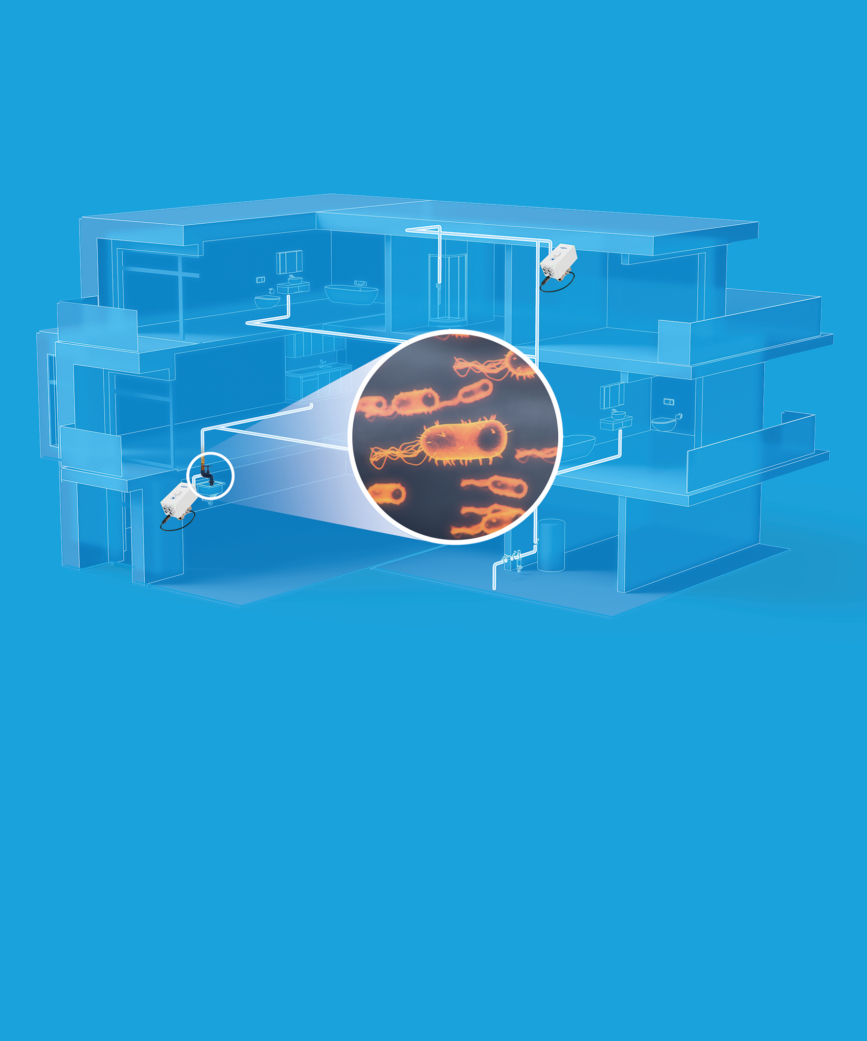 | GF_Hycleen_Flush_2.jpg  The risk of stagnation and Legionella growth increases particularly in buildings that are not used continuously or are used with varying intensity, such as hotels, schools, daycare centers, hospitals, retirement and nursing homes, office buildings, and vacation homes. The new Hycleen Flush digital valve from GF is a system for automated stagnation flushing, ensuring safe drinking water hygiene in cold and hot water pipes.  Source: GF
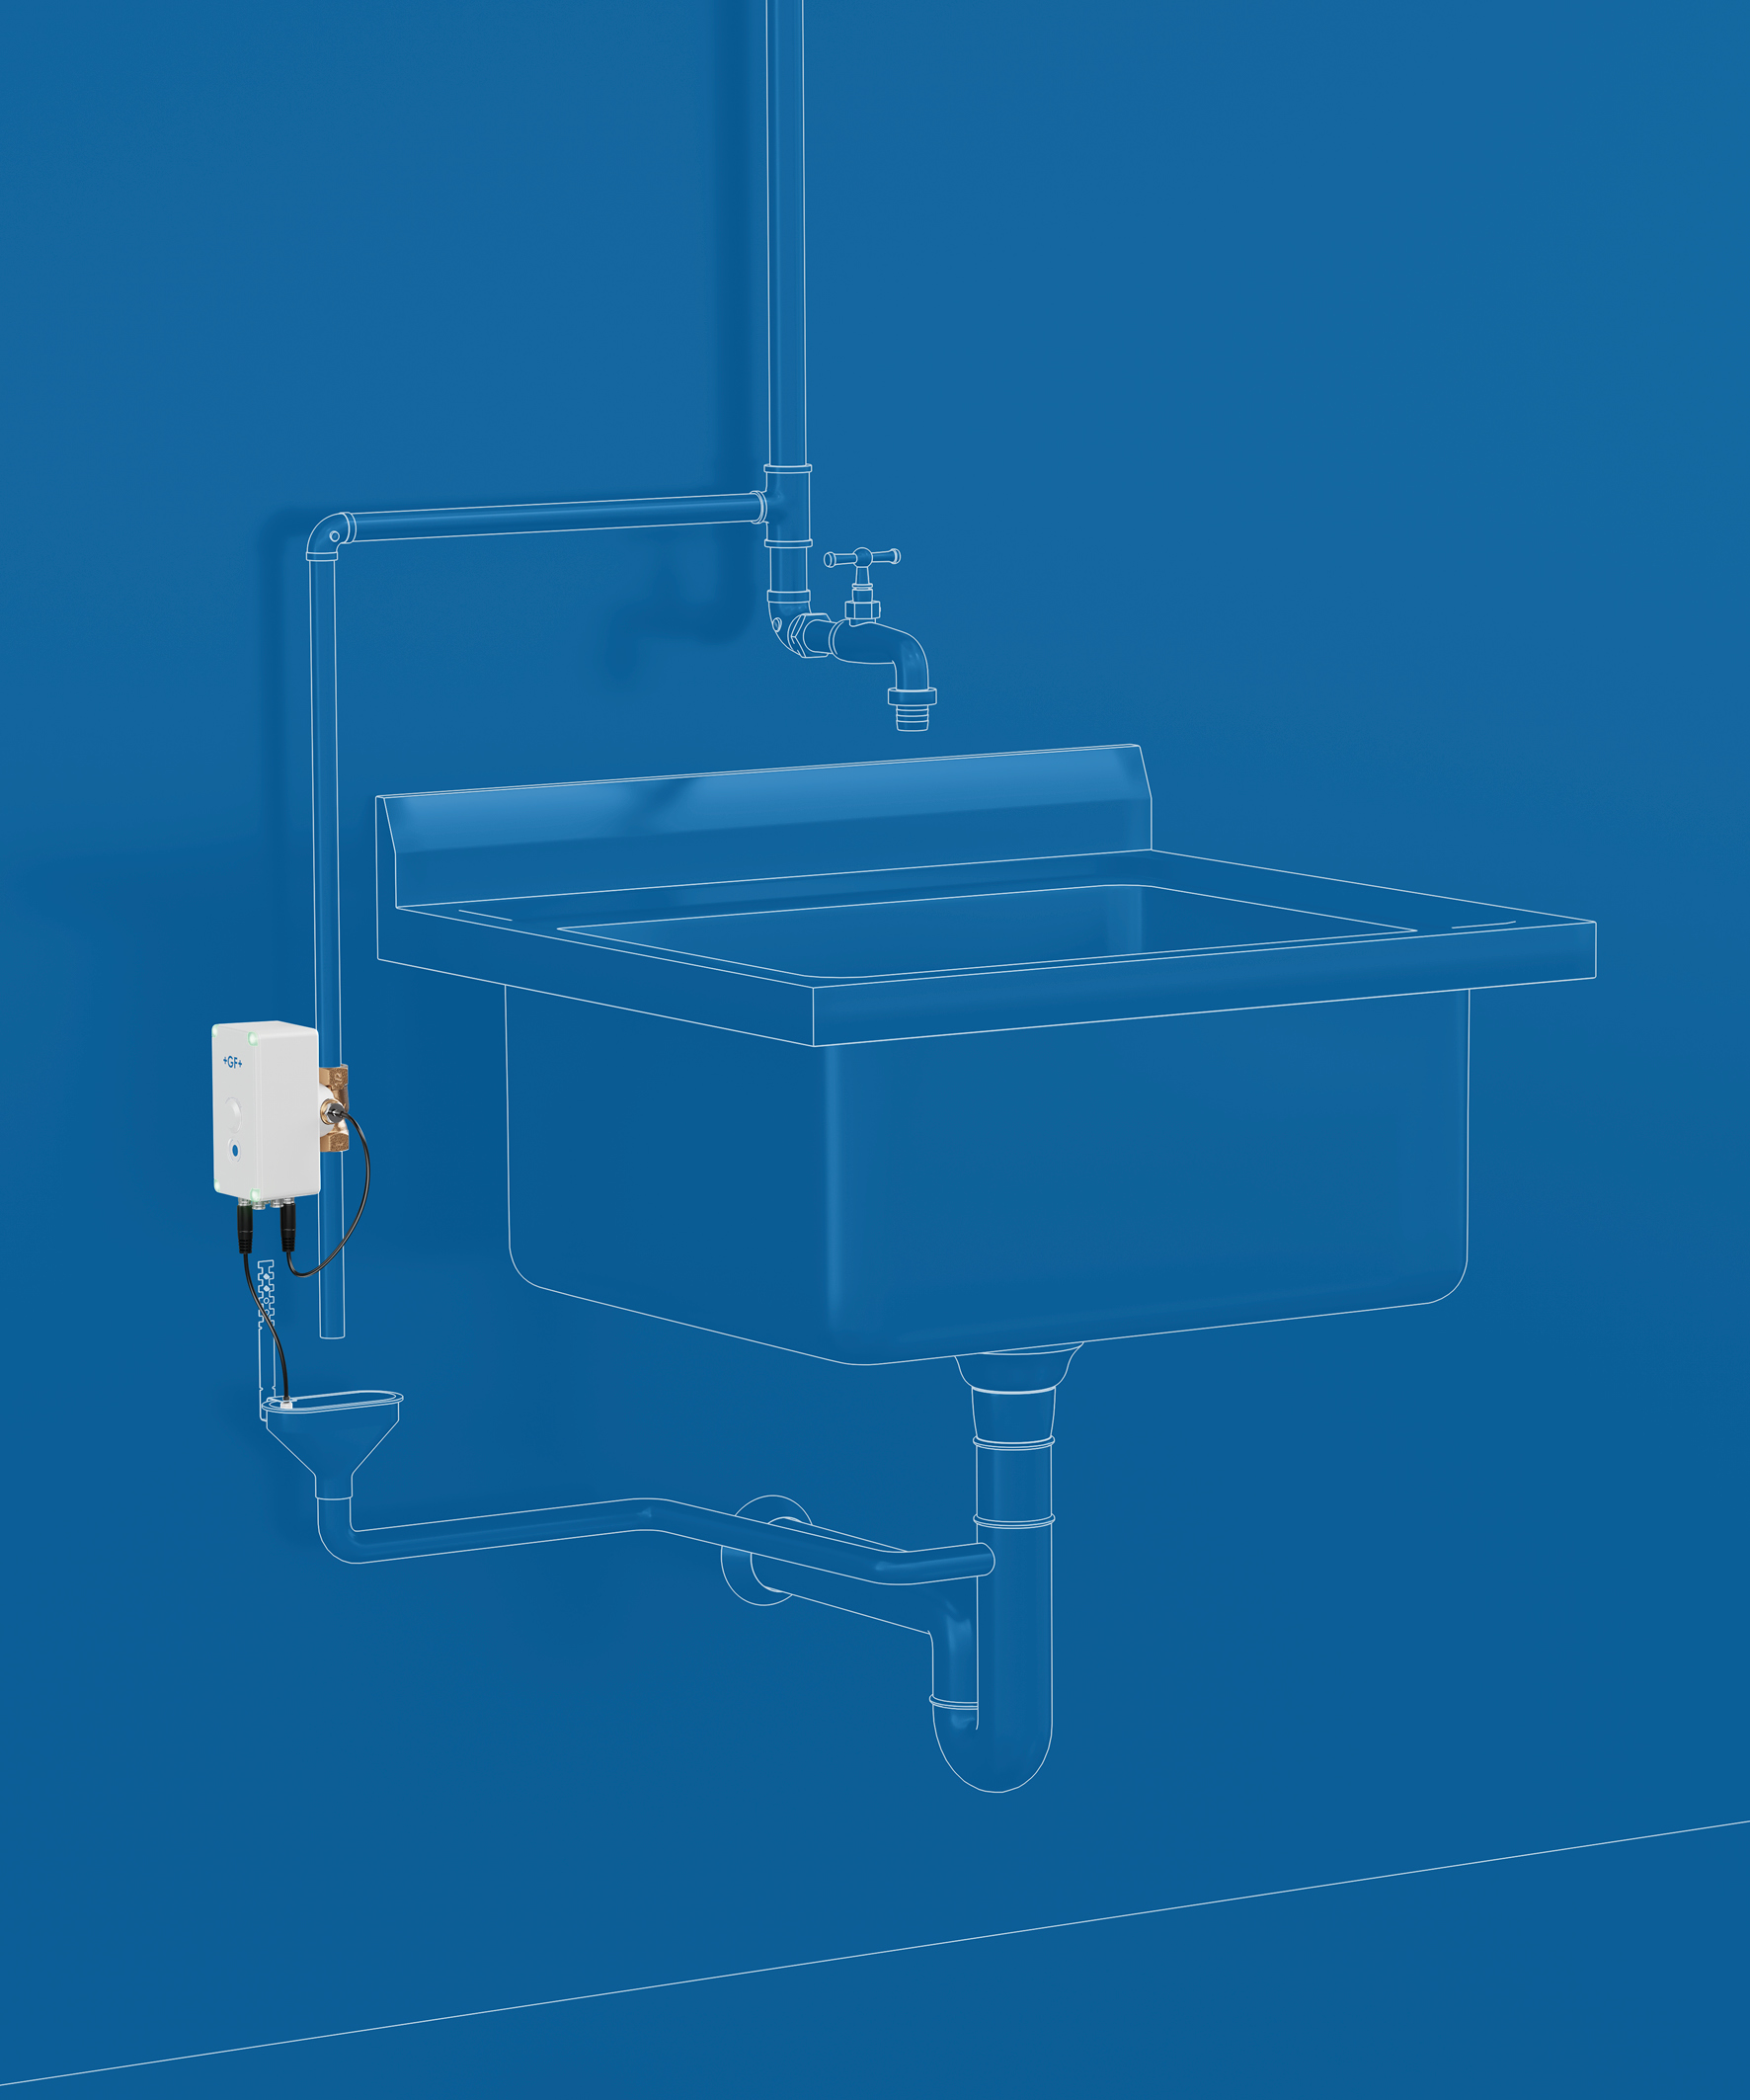 | GF_Hycleen_Flush_3.jpg  Flexible use, quick commissioning, documented processes: The digital valve is suitable for new buildings and renovations and, thanks to its compact size and uncomplicated installation, is ideal for retrofitting.  Source: GF
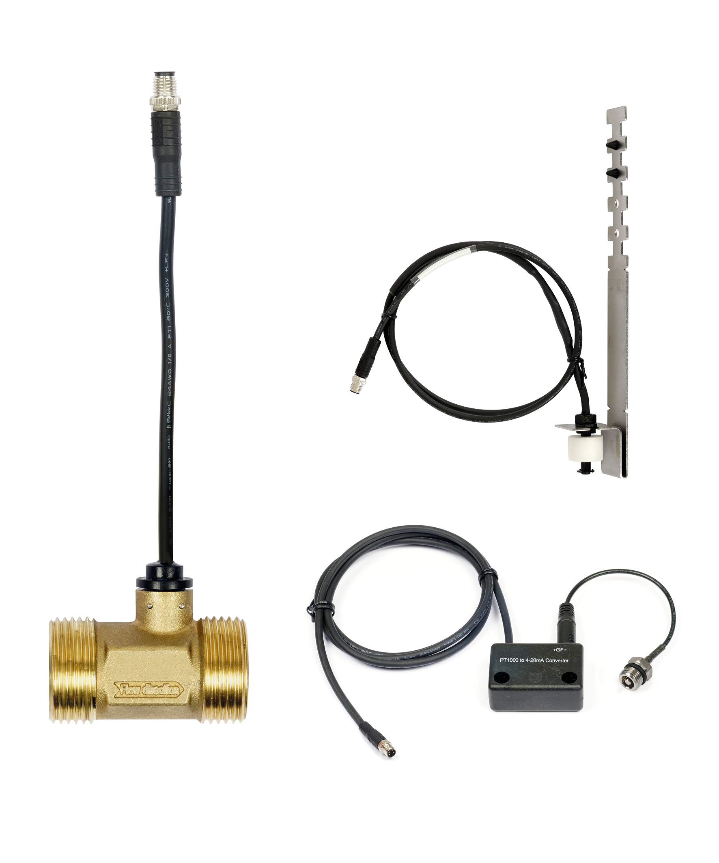 | GF_Hycleen_Flush_4.jpg  External sensors can be easily integrated for more comprehensive temperature monitoring in the building. External sensors can be integrated via the standard industrial signal 4–20 mA. This allows the connection of customer-specific measuring devices (e.g., for chlorine, pressure, or humidity). The system is compatible with proven Hycleen AS components such as flow sensors, additional temperature sensors, and drain monitoring.  Source: GF

