Media Release

Basel (Switzerland), 20. January 2026
New backwash filter pressure reducer combination from GF: Safety and reliability for drinking water installations
The new GF JRGURED Combi backwash filter reliably protects drinking water installations from particles from the public water supply while ensuring constant water pressure. Designed for maximum filtration performance and cleaning efficiency, the backwash filter with stainless steel screen can be maintained manually using a rotary handle. An automatic backwash system can be retrofitted as an option, making it ideal for use in less frequented properties. Automated maintenance reduces the effort required by homeowners and building managers alike.

An important component of durable and safe drinking water installations is the interface between the supply line and the domestic installation. Backwash filters ensure that particles from the public water network do not enter the domestic drinking water network, while pressure reducers regulate the water pressure and keep it constant. With the new GF JRGURED Combi backwash filter DN25-50, the market leader in flow solutions for buildings, industry, and infrastructure combines both functions in a powerful and easy-to-use product. The result is an efficient backwash filter with integrated JRGURED pressure reducer, which can be optionally retrofitted with automatic backwashing.

Purpose-driven design for efficiency and reliability
The new GF JRGURED Combi backwash filter is equipped with a large filter surface that ensures a consistently high flow rate. Made of stainless steel, the filter screen is located in a transparent filter cup made of high-quality plastic, which allows visual inspection of the filter condition. Thanks to the rotary pulse backwash technology, a short flushing sequence of 3 times 3 seconds is sufficient. A rotating, powerful, concentrated water jet effectively cleans the filter screen from the inside with low flushing water consumption.

Manual ease of use that can be automated
Backwashing is performed using an intuitive, ergonomic rotary handle with a clear position indicator. An integrated, rotatable monthly display makes it easy to mark the next backwashing date. For autonomous functionality, the filter can be retrofitted with an automatic backwash system. This eliminates manual flushing processes, which homeowners or building managers no longer have to think about. The automatic system is quickly installed directly on the filter in the form of a small controller, without the need for tools. To do this, the operating handle is removed, the device is connected to the power supply, and the desired flushing interval is selected. There are 10 different time programs available with flushing intervals ranging from 2 hours to 6 months. Thanks to an integrated battery, the system continues to operate reliably even in the event of a power failure. This makes the GF JRGURED Combi backwash filter the ideal and safe solution for buildings that are not in permanent use, such as vacation homes.

The GF JRGURED Combi backwash filter at a glance:

- Dimensions DN 25, 32, 40, 50 (1-2")
- Factory setting 4 bar, adjustment range 2 - 6 bar
- Filter with 100 μm mesh size
- Retrofittable automatic backwash system
- Rotational impulse backwash technology
- Filtered water even during backwashing
- Replaceable filter insert

For further information please contact
Beatrix Pfundstein
Senior Communications Manager
Building Flow Solutions
Global Communications
beatrix.pfundstein@georgfischer.com
Mobile +49 172 8599240

Corporate Profile
With a rich history in industrial innovation since 1802, GF is actively reshaping itself to become the global leader in Flow Solutions for Buildings, Industry and Infrastructure. GF delivers Excellence in Flow through essential products and solutions that enable the safe and sustainable transport of fluids worldwide. As part of its strategic transformation, GF divested GF Machining Solutions on 30 June 2025 and has signed an agreement to divest its GF Casting Solutions division. Headquartered in Switzerland, GF employs about 15’700 professionals and is present in 46 countries. GF generated sales of CHF 4’776 million in 2024. GF is listed on the SIX Swiss Exchange.
#ExcellenceInFlow
www.georgfischer.com
www.uponor.com
You can register for our subscription service for journalists at www.georgfischer.com/aboservice. You will automatically receive our current media releases.

Further information: GF JRGURED Combi Rückspülfilter | Uponor

Pictures
Reprint free of charge // please note the copyright information //
please provide copy of magazine or a link to the online publication

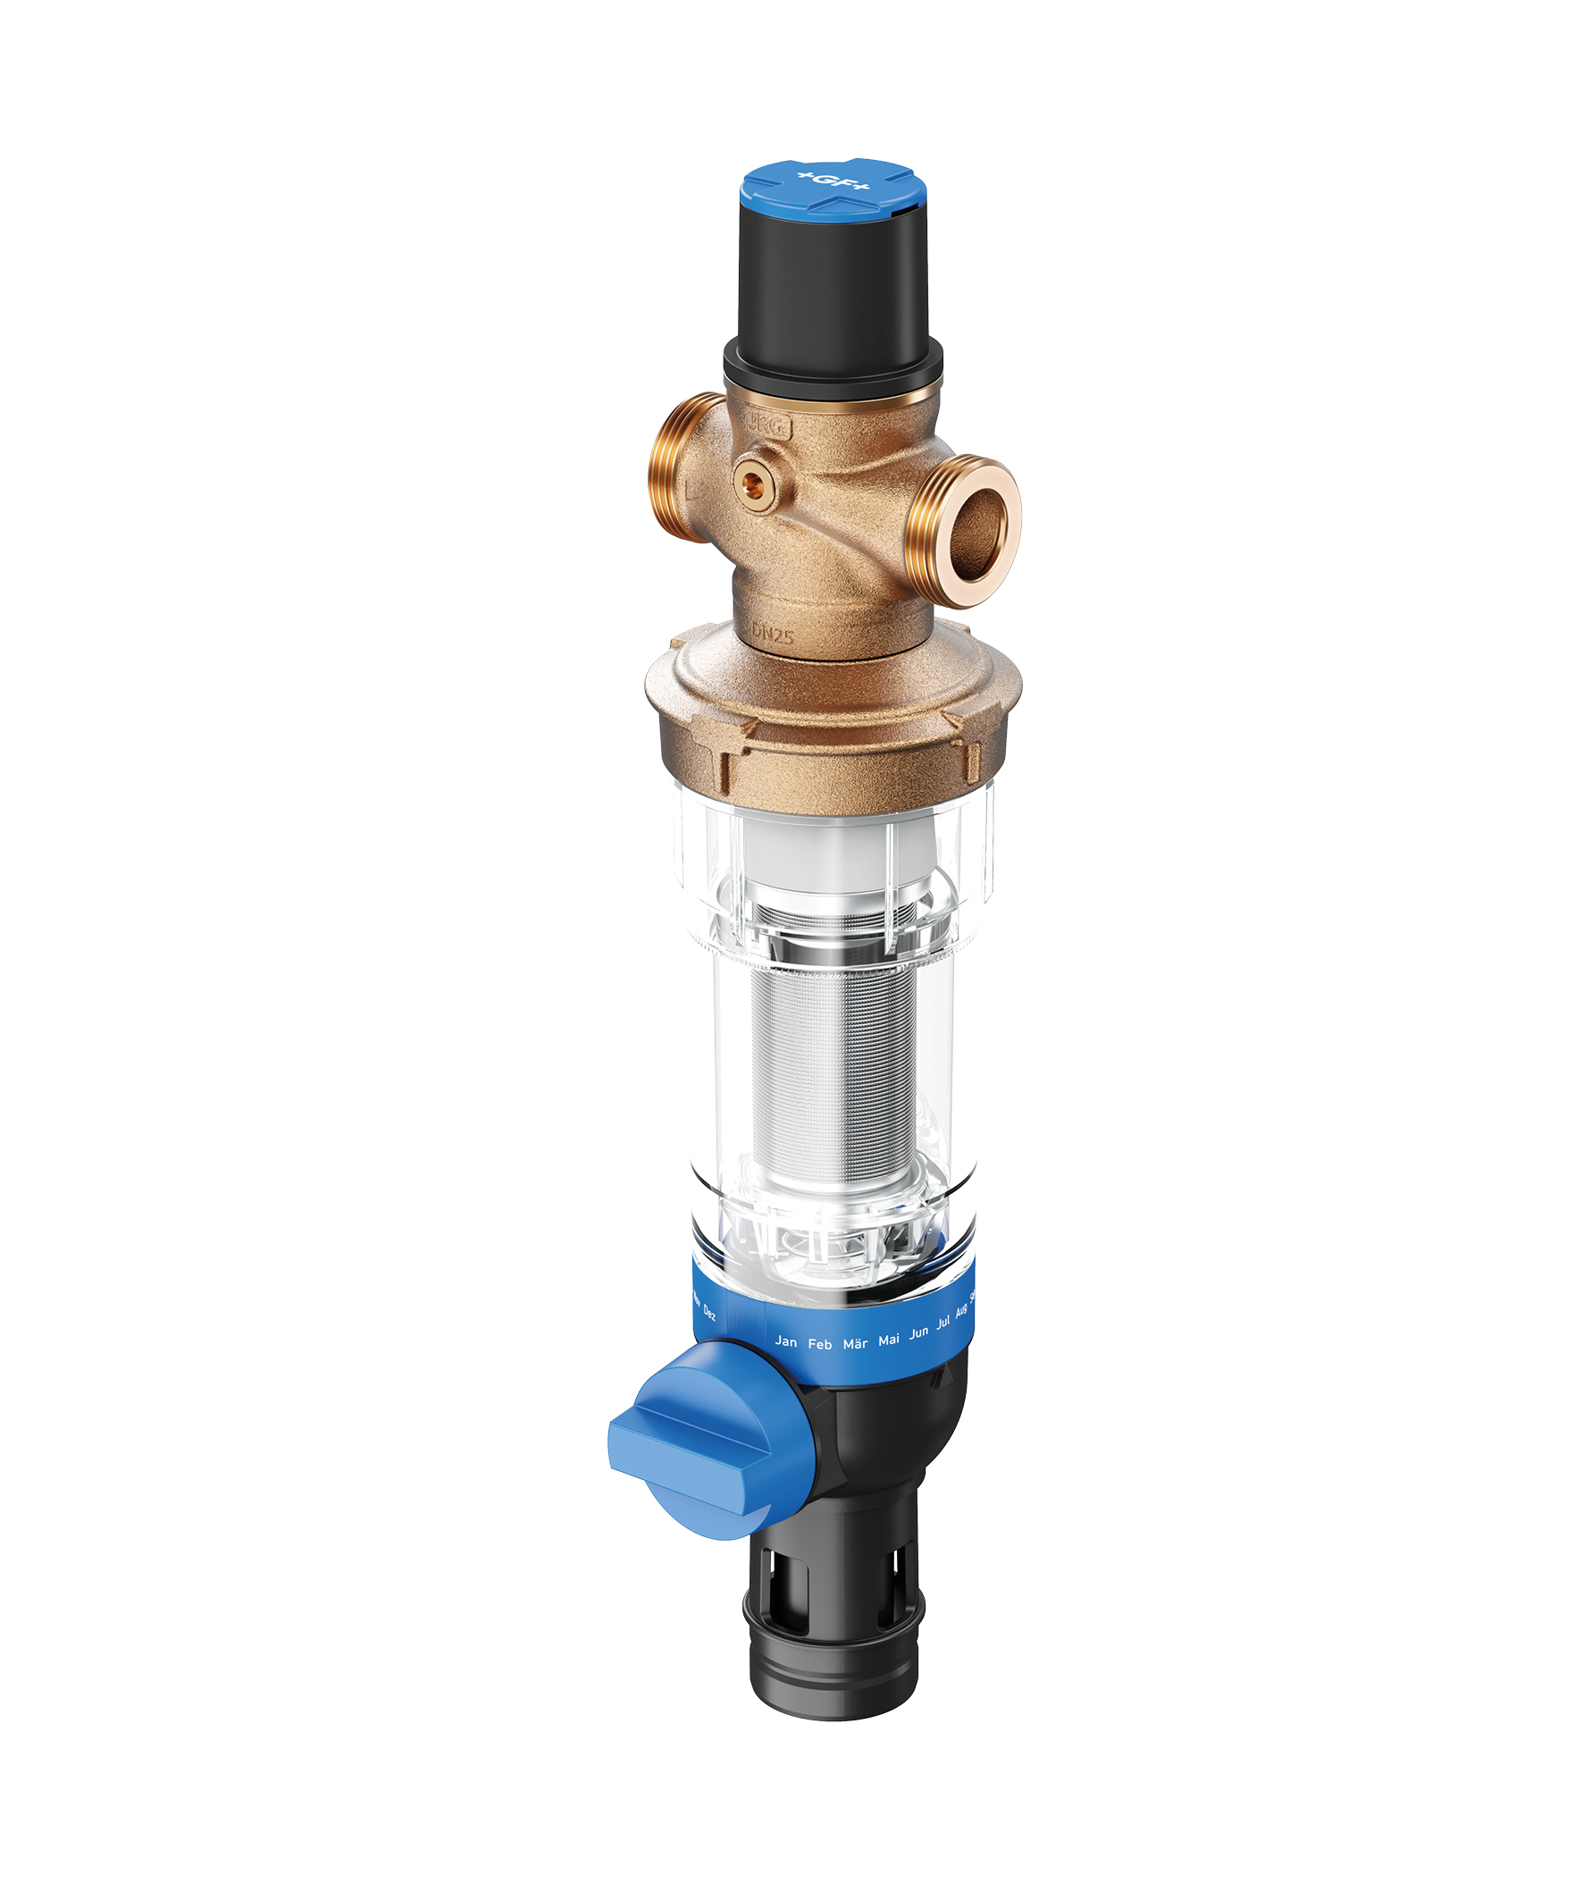 | GF_JRGURED_Combi_Backwash_Filter_1.jpg  The new GF JRGURED Combi backwash filter reliably protects drinking water installations from foreign particles from the public water supply while ensuring constant water pressure.  Source: GF
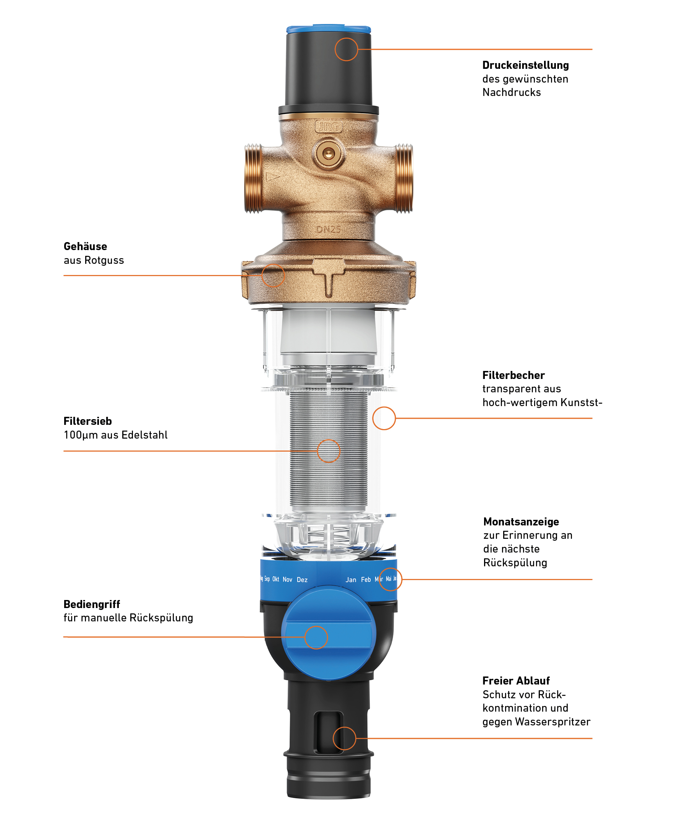 | GF_JRGURED_Combi_Backwash_Filter_2.jpg  The new GF JRGURED Combi backwash filter: Sophisticated design for a reliable and durable drinking water installation.  Source: GF
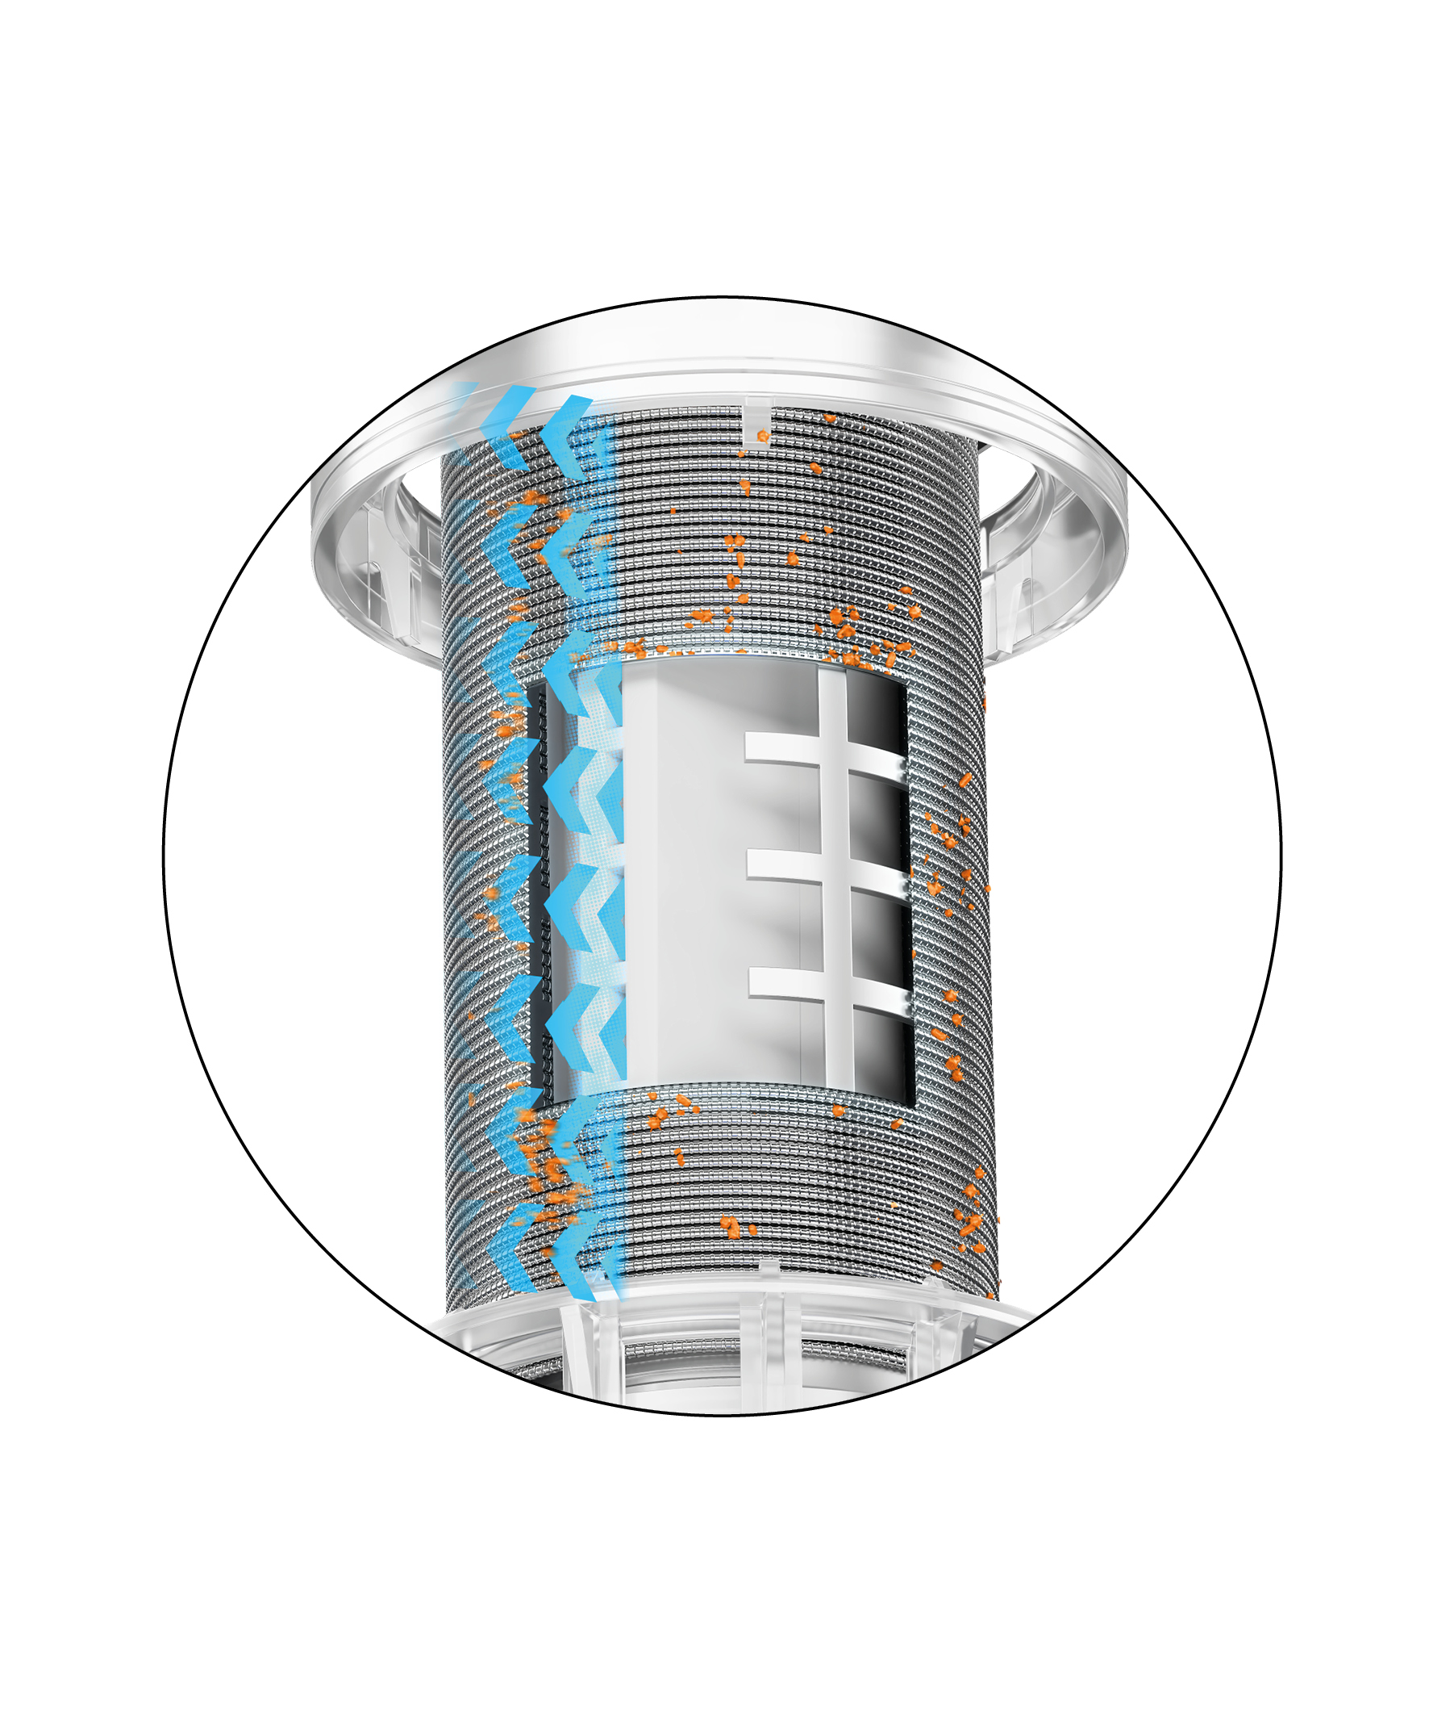 | GF_JRGURED_Combi_Backwash_Filter_2.jpg  Thanks to the rotational momentum backflush technology, a short flushing sequence of 3 times 3 seconds is sufficient. A rotating, powerful, concentrated water jet effectively cleans the filter screen from the inside with low flushing water consumption.  Source: GF
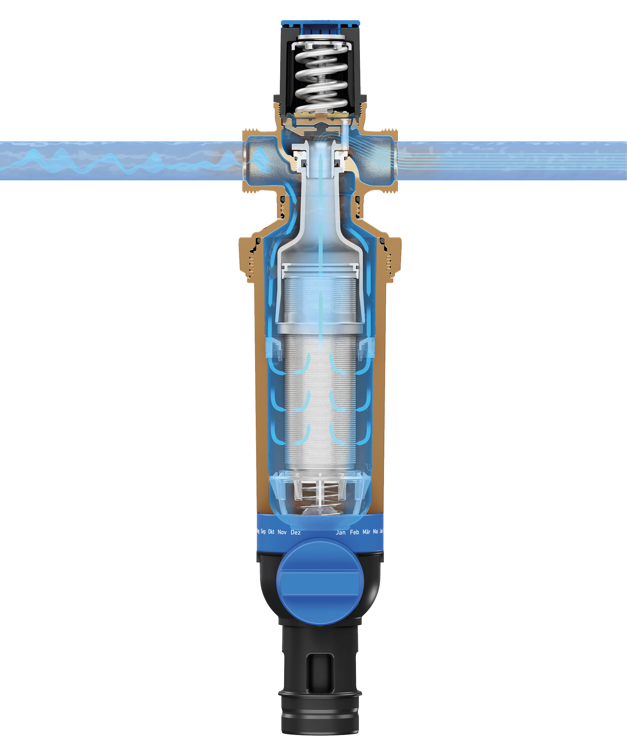 | GF_JRGURED_Combi_Backwash_Filter_2.jpg  The new GF JRGURED Combi backwash filter is equipped with a large filter surface that ensures a consistently high flow rate. Made of stainless steel, the filter screen is located in a transparent filter cup made of high-quality plastic, which allows visual inspection of the filter condition.  Source: GF
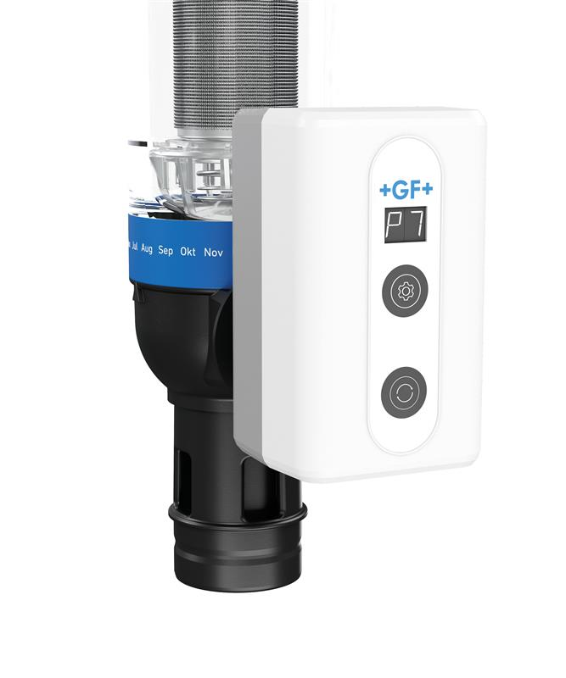 | GF_JRGURED_Combi_Backwash_Filter_2.jpg  For autonomous functionality, the GF JRGURED Combi backwash filter can be retrofitted with an automatic backwash system. This eliminates manual flushing, which homeowners or building managers no longer have to think about. The automatic system is quickly installed directly on the filter in the form of a small controller, without the need for tools.  Source: GF

