Media Release

Schaffhausen (Switzerland)
XX February 2026

From mountains to coastlines – wherever flow is needed:
GF’s multilayer pipe system Uponor Uni Pipe delivers
flexibility, reliability and installation benefits
The Uponor Uni Pipe & S-Press multilayer composite pipe system offers a high-performance solution for modern drinking water and heating installations. It meets the highest standards of hygiene and installation safety, while enabling particularly efficient and easy-to-use implementation in a variety of applications. With more than 500 million press fittings, the multilayer composite pipe system has proven itself as a reliable solution for a wide range of applications. Installers worldwide rely on Central European development and production quality – and benefit from simplified work processes for reliable drinking water and heating installations.

Whether on the summit of Germany's highest mountain or in Spain's Mediterranean climate, GF's Uponor Uni Pipe & S-Press multilayer composite pipe system offers flexibility, reliability, and installation advantages. The pipe structure, consisting of a seamless or using OW technology manufactured aluminum core, not only prevents oxygen from entering, but also compensates for the restoring forces and linear expansion caused by temperature changes. The inner/outer layer is made of high-temperature-resistant polyethylene (according to DIN 16833). This multi-layer composite forms the basis for a safe and fast drinking water connection or for connecting energy-efficient heating systems. The Uni Pipe PLUS composite pipe is connected with S-Press PLUS fittings made of corrosion-resistant brass or high-performance PPSU. With installation advantages such as up to 30% less bending force, a bending radius that is up to 40% tighter, and a weight that is three times lighter than copper, the Uponor Uni Pipe & S-Press system offers installer-friendly, value-adding solutions for drinking water and heating installations.

Overcoming unique challenges while taking reliability and comfort to new heights
The station at the top of Germany's tallest mountain, the Zugspitze, is visited by over half a million people every year. A world-record breaking cable car transports tourists to the summit, which offers breathtaking views of the German, Austrian, Italian and Swiss Alps. The restaurant offers indoor space for up to 450 plus outdoors for 850 more guests. The Zugspitze is not only the coldest place in Germany, but also its sunniest, having long averaged 1,800 annual hours of sunshine.

Visitors enjoy the warm interior ambiance of the Panorama 2962 summit restaurant all the more because outdoor air temperatures atop the Zugspitze rarely climb higher than five degrees Celsius (41°F), even in midsummer. 720 m² of Uponor underfloor heating solution Classic ensure comfortable radiant heat throughout the restaurant's interior. For the heating line connection and the drinking water distribution system, the planers and installers opted for the Uponor multilayer composite pipe system. The radiators and heating distributors for the underfloor heating system are connected by 250 meters of the multilayer pipe system Uponor Uni Pipe PLUS with sizes ranging from 16 to 40 mm.

Every day, 6,000 liters of drinking water are pumped from the valley station at Eibsee to the mountain station. The drinking water supply is distributed over four floors via 500 m of distribution and riser pipes using the Uponor composite pipe system. The main consumers are the kitchen and the toilet facilities. „Naturally, the Top of Germany needs top quality”, says Erwin Bouvier, Managing Director of the Bouvier Group who was responsible for the installation of the products.

Building at 2962 meters above sea level presented unique challenges, especially while ensuring that water utilities were fully operational throughout the process. Michael Singer, project manager for Zugspitze mountain station, summarized the situation at the time: “I had to specify the goods to be transported and the exact weight one week in advance and then I was assigned a time window. We quickly cleared out the transport crates on the roof, as the space was already needed for the next material delivery.“

Award-winning project in Portugal's capital relies on Uponor multilayer composite pipes
In ALLO – Alcântara Lisbon Offices, the Uponor Uni Pipe composite pipe system proves its strengths in yet another project. The modern office complex in Lisbon, Portugal, which won the Expresso and SIC Notícias Real Estate Awards in the categories “Best Project” and “Best Offices,” sets new standards in both architecture and technology.

The flowing, horizontally structured façade design blends harmoniously into the surroundings of the dynamically growing Alcântara district. With energy efficiency class A, an integrated photovoltaic system, and architecture that makes consistent use of daylight, ALLO offers optimal conditions for technology and innovation companies.

Uponor Uni Pipe composite pipes were used for the building's water transport system – a solution that has proven to be reliable, easy to install, and particularly powerful. Thanks to their high stability, low linear expansion, low pressure loss, and excellent resistance to hydrostatic stress, they meet all requirements and regulations for drinking water installations.

Urbanism of the future: blending sustainability and comfort
Cartuja Qanat is a groundbreaking urban transformation project that redefines the concept of public space. Nestled in Sevilla, Spain, this innovative endeavor represents the urbanism of the future, fostering environmental comfort, social interaction, and sustainable urban growth. At its core: the invisible radiant cooling system Uponor Thermatop M. Integrated seamlessly into 700 m² of unique ceiling, the system features nine panels with varying inclinations, 125 distribution circuits using Uponor Uni Pipe PLUS, and 14 prefabricated Uponor Comfort Port Duo manifolds. The design uses underground ducts to naturally generate hot and cold water and airflow, improving efficiency while reducing environmental impact. After initially evaluating an active floor system, the development team led by Grupo Termotecnia at the University of Seville selected Uponor’s Thermatop system as the optimal solution, combining the benefits of active underfloor systems with low thermal inertia for fast response times. Cartuja Qanat sets a new global benchmark for urban development, blending technology, sustainability, and inviting spaces into a powerful testament to innovation and environmental stewardship for a brighter future.

“GF offers the widest range of horizontal and vertical hot and cold-water distribution, providing solutions across applications for safe hygienic drinking water and energy efficient heating installation”, says Torsten Meier, Chief Innovation Officer, GF Building Flow Solutions. “With reliable products like Uni Pipe and the S-Press PLUS system, backed by our expertise and support, we help installers, contractors, and builders plan and complete projects efficiently – while navigating labor shortages and rising material costs.”

More about Uponor Uni Pipe & S-Press: Multilayer pipe system | Uponor

For further information please contact
Beatrix Pfundstein
Senior Communications Manager
Building Flow Solutions
Global Communications
beatrix.pfundstein@georgfischer.com
Mobile +49 172 8599240

Corporate profile
With a rich history in industrial innovation since 1802, GF is reshaping the future of Flow Solutions by delivering Excellence in Flow through mission-critical products and solutions that enable the safe and sustainable transport of water and other fluids for Buildings, Industry and Infrastructure. Headquartered in Switzerland, GF employs around 13’300 professionals across 46 countries. In 2025, GF’s Flow Solutions business generated sales of CHF 3 billion. GF is listed on the SIX Swiss Exchange. For more information, visit www.georgfischer.com.
#ExcellenceInFlow

You can register for our subscription service for journalists at www.georgfischer.com/aboservice. You will automatically receive our current media releases.

Pictures
Reprint free of charge // please note the copyright information //
please provide copy of magazine or a link to the online publication

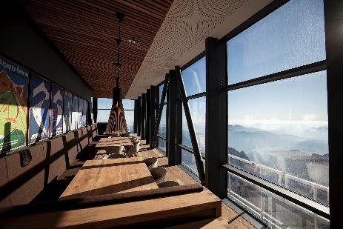 | Panorama_2962.jpg  The restaurant Panorama 2962 at the top of Germany's tallest mountain the Zugspitze offers indoor space for up to 450 plus outdoors for 850 more guests.  Building Owner:  Bayerische Zugspitzbahn Bergbahn AG  www.zugspitze.de  Design:  Johannes Hasenauer, Technisches Büro GmbH, Maishofen  www.tb-hasenauer.at  Construction:  Luzian Bouvier, Haustechnik & Fliesen GmbH, Pflach  www.bouvier.at  Photo: Matthias Fend
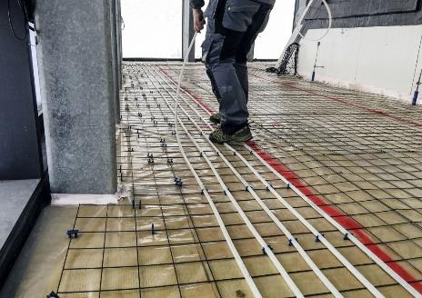 | Uponor_Classic.jpg  In the Panorama 2962 Zugspitze summit restaurant, 720 m² of Uponor underfloor heating solution Classic (in the picture) ensure comfortable radiant heat throughout the restaurant's interior.  The drinking water supply is connected on four floors via 500 m of distribution and riser pipes using the Uponor composite pipe system.  Source: Bayerische Zugspitzbahn Bergbahn AG
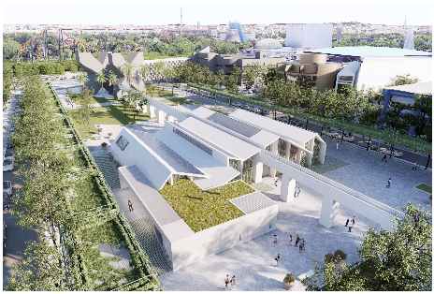 | Cartuja_Quanat_1.jpg  Cartuja Qanat is a groundbreaking urban transformation project that redefines the concept of public space. Nestled in Sevilla, Spain, this innovative endeavor represents the urbanism of the future, fostering environmental comfort, social interaction, and sustainable urban growth.  Photo: Cartuja Qanat
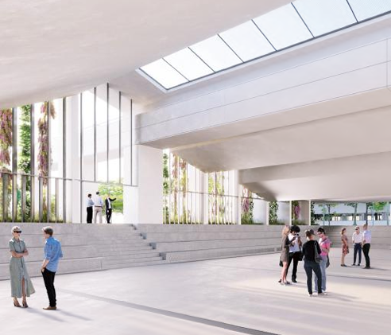 | Cartuja_Quanat_2.jpg  Uponor Thermatop M is integrated seamlessly into 700 m² of unique ceiling, the system features nine panels with varying inclinations, 125 distribution circuits using Uponor Uni Pipe PLUS, and 14 prefabricated Uponor Comfort Port Duo manifolds.  Photo: Cartuja Qanat
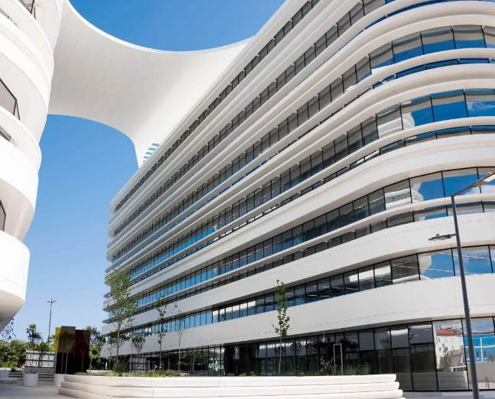 | ALLO_Portugal.jpg  Uponor Uni Pipe composite pipes were used for the water transport system in the ALLO – Alcântara Lisbon Offices – a solution that has proven to be reliable, easy to install, and particularly high-performance. Thanks to their high stability, low linear expansion, low pressure loss, and excellent resistance to hydrostatic stress, they meet all requirements and regulations for drinking water installations.  Photo: GF
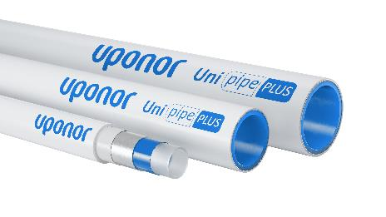 | Uponor_Multilayer_Pipes.jpg  The Uponor Uni Pipe & S-Press multilayer composite pipe system offers a high-performance solution for modern drinking water and heating installations. It meets the highest standards of hygiene and installation safety, while enabling particularly efficient and easy-to-use implementation in a variety of applications.  Source: GF

